Log into the www.atitesting.com site
Click on the three dots in the upper right corner

Click on Online Store
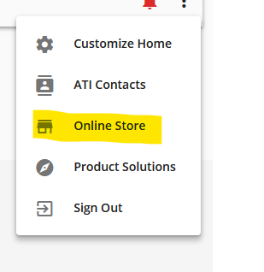

Choose TEAS
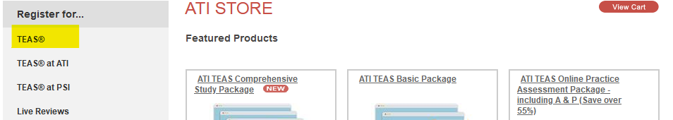

Fill out the form from the drop down menus

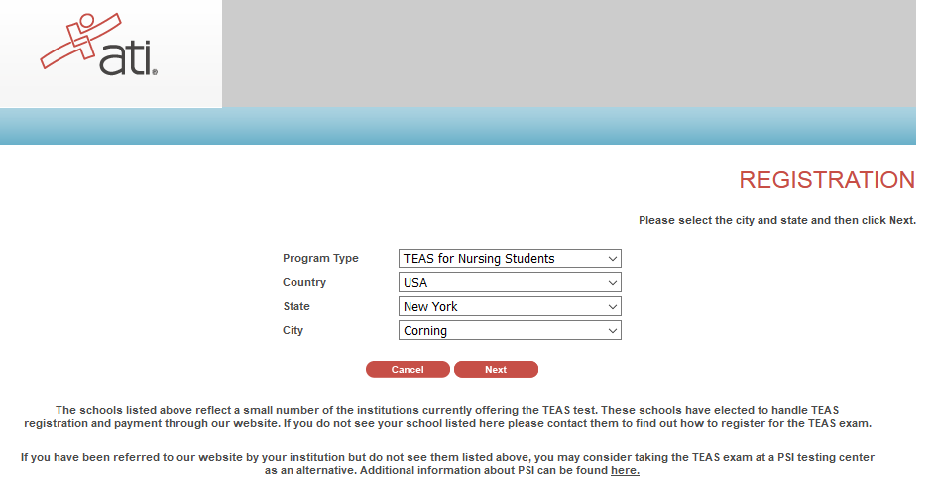
Click Next and the available dates and times will appear
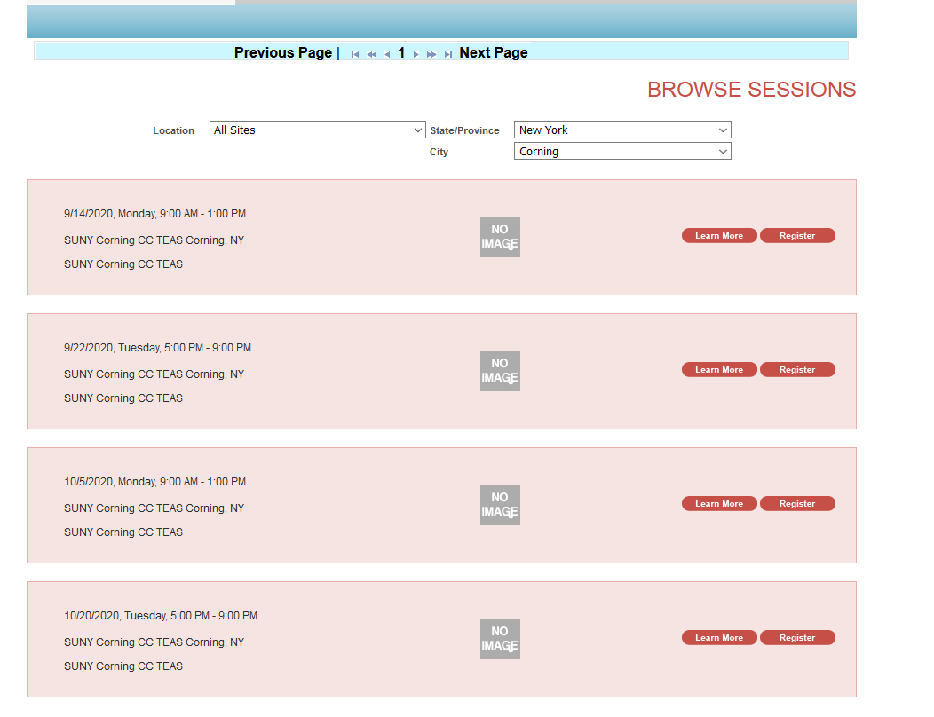
Click on Register for the date and time of your choice.

