Corning Community College Nurse Education
1 Academic Drive
Corning, New York 14830
(607) 937-1323
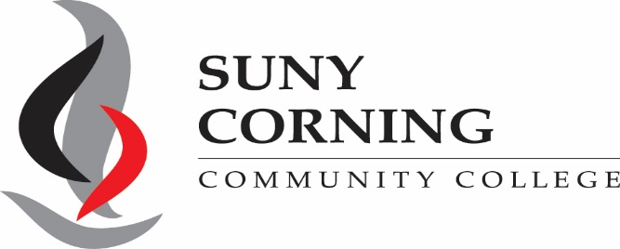
1 (800) 358-7171 ext. 1323

Application for Direct-Entry Admission

SUNY CORNING COMMUNITY COLLEGE PROFESSIONAL STUDIES DIVISION AND ADMISSION OFFICE
ASSOCIATE OF APPLIED SCIENCE IN NURSING
The Freshman Direct-Entry Admission track is for currently enrolled high achieving high school seniors who are preparing to enter SUNY Corning Community College in the fall following their May/June high school graduation.

SUNY Corning Community College’s Nurse Education program offers direct-entry for high school students who are dedicated to completing their Associate of Applied Science in Nursing degree in two years. With direct entry into our nursing program, a student’s academic path is secure. The Freshman Direct-Entry Admission track is for currently enrolled high achieving high school seniors who are preparing to enter SUNY Corning Community College in the fall following their May/June high school graduation.
The Freshman Direct Admit is a full-time two-year program. The nursing program at SUNY Corning Community College is an exciting and challenging program. In the very first semester, students start learning clinical skills they will need to create a solid foundation for future clinical practice. By the end of the first semester, they will have the opportunity to use those skills in the clinical setting.

Success in the program takes a firm commitment from each student and SUNY Corning Community College (CCC) offers many services that are aimed at helping you succeed. Nursing is a demanding field and admission to nursing schools is a very competitive process. We strongly suggest you prepare well by meeting with an advisor in order to help you with your educational and career plans, by reading the application materials thoroughly and, if possible, talking with nurses in various settings to gain better understanding of the role of a nurse.
Admission is competitive and high school students must demonstrate strength in biology, chemistry, and mathematics. In addition to the requirements below, it is recommended that applicants for the Direct Admit track should have completed upon graduation from high school, one year each of biology, chemistry, algebra, and geometry. It is also recommended that students have three years of high school math, and a science in the senior year.

A selected group of high achieving high school seniors admitted to SUNY Corning Community College may secure a seat in the Nurse Education Program by meeting, at a minimum, the following criteria:
- Admitted to SUNY Corning Community College
- A cumulative high school GPA of 3.50 (on a 4.0 scale) or its equivalent or graduated in the top 20% of high school class.
- Completed high school chemistry and biology with a grade of 90% or higher
- Submit a complete Direct-Entry application file. A complete file includes:
  - Application for Direct-Entry Admission
  - Two Nursing Reference Forms. One of these should come from a core (Math, Science, English, Social Science) teacher, preferably a science teacher.
  - ATI TEAS Assessment Admission Report with minimum of 58.7% overall score
- Prepare a typed, two-page essay responding to each of the following statements. Essay will be evaluated on the basis of content, writing ability, clarity of thought and sequence of ideas.
  - Discuss the development of your interest in nursing; how your background and experience played a part in this development. These might include experiences in health care, community service, life experiences and/or mentor.
  - Discuss what qualities and attributes do you believe you possess that will enable you to be successful as a student and future nurse?
  - How will your role as a Registered Nurse impact the nursing profession?
- Meet all other requirements for admission to the nursing major prior to matriculation.

Essay Information
Your essay will be reviewed by the Admissions Committee and/or nursing faculty. The essay will be evaluated based on an established grading rubric. A copy of the grading rubric is provided below. This essay will help to provide evidence of your ability to communicate effectively through written words.
Language, grammar and expression of ideas will be reviewed for clarity and creativity. Attention will be placed on formatting requirements as being indicative of the ability to follow directions. If there is evidence of plagiarism, the essay will not be graded and the applicant will not be accepted to the program.

Essay format:

- Two pages
- Typed doubled-spaced pages (8x11) with one-inch margins
- Times New Roman 12-point font
- At the top of the page please include the following information:
o Name and Student ID Number

Rubric for Nursing Admission Essay
Criterion | Below Average (1) | Average (2) | Good (3) | Excellent (4) | Score
Content | Thesis is not clear/not well developed | Main idea addresses prompt/has thesis | Main idea addresses prompt/well developed and consistent thesis | Main ideas addresses prompt /well developed and consistent thesis
Organization | There is little or no organization of the essay’s content. | The essay is difficult to follow because of inadequate transitions and/or  disorganized format | The essay flows logically, can be easily followed, and professionally written  with some exceptions | The essay flows logically and can be easily followed. The essay is professionally written
Spelling, Grammar, and Formatting | Major mechanical errors (subject/verb agreement, fragments, etc.) The essay is difficult to  read and understand (>10 errors) | Some mechanical errors (5-10 errors ) | Relatively free of mechanical errors; complex and varied sentence structure (<5 errors) | Completely free of mechanical errors
Motivation for Nursing | No sense of caring or altruism is demonstrated. Voice is not personal. | Caring and altruism is mentioned; however, the ideas are not supported by examples of personal motivation and experiences.  Voice is generally impersonal | Caring and altruism discussed; however, the ideas are minimally supported by examples of personal motivation and experiences. Voice is generally individualistic | Caring and altruism is evident throughout the essay supported by multiple examples of personal motivation and experiences. Voice is strongly individualistic
TOTAL

AAS NURSING DIRECT-ENTRY ADMISSIONS RUBRIC

Name: CC ID #

Selection into the Direct-Entry Nurse Education program is very competitive and based on calculation of quality points earned in the following courses. Applicants are then ranked from the highest to the lowest number in points and admission is granted to the direct-entry program to the students with the most points. Must meet minimum pre-requisite course work and scores for consideration:

Rubric for Nursing Direct-Entry Admission
Program Requirements | Scale | Possible Points | Points Earned | Comments | Score
Cumulative GPA | 3.8-4.0=10  3.7-3.6=7  3.5-3.3=5  3.2-3.0=3  <3.0=0 | 10
Biology | >90%=10  89-87%=7  86-84%=5  83-81%=3  <80%=0 | 10
Chemistry | >90%=10  89-87%=7  86-84%=5  83-81%=3  <80%=0 | 10
Algebra | >90%=10  89-87%=7  86-84%=5  83-81%=3  <80%=0 | 10
Essay | See Rubric | 16
Extracurricular Activities | >6 activities=6  3-5 activities=4  1-2 activities=2  0 activities=0 | 6
Community Service | Yes=2 No=0 | 2
Work Experience | Health-related=4  Non-Health- related=2 | 4
Additional Points Completed College level courses | Anatomy & Physiology I and II  Intro to Sociology Intro to Psychology Calculus/Statistics  English Comp I | 6
Total Points |  | 74

Timeline of Communication with Applicants and What to Expect

Application Submission
- All required items and the nursing application form must be submitted TOGETHER at one time.
- Submit your application via email to the Nurse Education Department from January 25, 2021 through March 1, 2021 to cccnursing@corning-cc.edu
- All application packets must be submitted by the due date of March 1, 2021 @ 11:59 pm.
- You will receive a confirmation email when your application has been received.

Incomplete Application
- It is your responsibility to ensure that all requirements have been met. Incomplete applications or applications missing documentation will not be considered! Applicants are advised to review their application packet thoroughly before submitting.

Decisions
- All applicants will be notified by email (your SUNY Corning Community College student email account) about the Admissions Committee decision during the first week of APRIL 2021. Please do not contact the Nurse Education Department before you receive your email.

Acceptance Process
- The order of acceptance of qualified Direct-Entry applicants will be determined by the highest ranking. Those with the highest ranking who have met all criteria are offered one of the 10 seats.
- If a student is denied admission to the Direct-Entry Nurse Education program, he/she may take courses towards program requirements and reapply for the next fall admission.
- Once admitted, if a student chooses not to accept a seat in the Direct-Entry program for that fall following high school graduation, he/she will need to reapply for the next fall and compete with applicants for that semester.
- Upon acceptance into the Direct-Entry Nurse Education program, a student will be required to have a yearly physical examination, immunizations, fingerprinting, COVID-19 testing, drug screening, background check and AHA - BLS CPR certification. NOTE: Corning Community College Nurse Education Department requires CPR for the Healthcare Provider through the American Heart Association.
- All fees for required immunizations, physical, COVID-19 testing, drug screening, background checks and child abuse screening are the responsibility of the applicant. Instructions will be sent with the acceptance letter.
- Admitted direct-entry students will be required to attend a mandatory 3-day Boot Camp held in August. During Boot Camp, important information about the program, college support systems, textbooks, uniforms, software, and other required items will be presented.
- The Nurse Education Department sends all electronic correspondence to students via their SUNY Corning Community College e-mail accounts. No personal e-mail addresses will be used.

To be completed by CCC representative only

Date Received: Initial:

Application for Direct-Entry Admission

Please include the following required documents with the direct-entry packet:
- Reference Forms
- Unofficial High School Transcript
- Unofficial College transcript, if applicable
- ATI TEAS Admission Assessment Report
- Essential Functions Form
- Signature Page
- Confidential Waiver
- Activities List
- Essay

Name

Last First Middle Initial

Mailing address

House# / Apt# / P.O. Box / Rural route Street name

City State Zip code

Birthdate: _ CCC CID# C LAST 4 of SS#

County of Residence: Chemung Schuyler Steuben Other - please identify

High School Name & Graduation Date

Phone # Daytime Home Phone _

Cell _ Work Phone

Personal e-mail _ College e-mail address _

HAVE YOU EVER BEEN CONVICTED OF A FELONY? YES NO

On a separate sheet of paper please list extracurricular activities, work experience, community service, awards, and leadership positions you have held while in high school.

DEPARTMENT OF NURSE EDUCATION ESSENTIAL FUNCTIONS FOR ADMISSION
The Essential Functions for Admission of a nursing applicant/student enrolled in the ADN program requires that a student, with or without reasonable accommodations, must be able to:

- Demonstrate the ability to perform essential functions for a maximum of a 12-hour shift.

- Demonstrate the ability to protect a patient when the patient is standing and ambulating on all surfaces with or without the use of assistive devices, including canes, crutches and walkers.

- Demonstrate the ability to safely move a patient over 100 pounds from one surface to another using the appropriate level of help.

- Demonstrate safe body mechanics in the process of all patient treatments, including lifting and carrying small equipment (under 50 pounds) and moving large equipment (over 50 pounds).

- Demonstrate the ability to manipulate dials on equipment.

- Demonstrate the ability to coordinate simultaneous motions.

- Demonstrate the ability to perform occasional overhead extension.

- Demonstrate the ability to hear blood pressure, heart and lung sounds with or without corrective devices.

- Demonstrate the ability to palpate soft tissue including pulse, muscle and bones.

- Demonstrate the ability to perform nursing interventions such as sterile procedures, dressing changes and administer medications (including dosage calculations when necessary) following infection control procedures.

- Display adaptability to change.

- Establish effective relationships with others.

- Communicate effectively, safely and efficiently in English by:

  - Explaining procedures
  - Receiving information from others
  - Receiving information from written documents

- Distinguish color changes.

- Detect an unsafe environment change and carry out appropriate emergency procedures including:
- Detecting subtle environmental changes and odors including but not limited to the smell of burning, smoke and spills.
- Detect high and low sounds, including but not limited to alarms, bells, and emergency signals.

Please read, sign, and submit the Essential Functions for Admission Certification Form included on the next page.

ESSENTIAL FUNCTIONS FOR ADMISSION

Certification Form

Corning Community College seeks to provide equal access to its program, services and activities for people with disabilities. These standards have been prepared to help applicants for admission to Corning Community College Nurse Education Program. You are encouraged to ask questions about the program’s essential functions for admission to clarify any questions and to determine whether you can meet the requirements with or without reasonable accommodation. Any information and inquiries about disabilities are handled in a confidential manner, to the extent possible within the accommodation process, and should be directed to the Office of Student Accessibility Services

INSTRUCTIONS:
Please check one of the choices below. Sign, date, and return this form with your application packet.

I certify that I have read and understand the Essential Functions for Admission to Corning Community College Nurse Education Program and that I meet each of these standards established for this program to which I am applying.

Signature Corning Community College ID Number

Printed or Typed Name Date

I certify that I have read and understand the Essential Functions for Admissions to Corning Community College Nurse Education Program. I believe that I could meet the Essential Functions with accommodation, and will contact the Office of Student Accessibility Services to determine whether reasonable accommodations can be made.

Signature Corning Community College ID Number

Printed or Typed Name Date

SIGNATURE SECTION
- I understand that it is my responsibility to determine that all my requirements have been met, and if all requirements have not been met and my application is incomplete upon submission, it will not be reviewed, will be deemed ineligible, and denied.

- I understand that late application packets will not be accepted.

- I understand that this application does not guarantee admission to SUNY Corning Community College Direct-Entry Nurse Education Program.

- I agree that all statements made in this application packet are true to the best of my knowledge, and I understand that providing false information will exclude me from acceptance or can be cause for my acceptance to be rescinded from this program.

Print Name Date

Signature

All paperwork submitted becomes the property of Corning Community College and will not be returned. We encourage you to make copies for your files.

Please contact the Nurse Education Department if you have questions

SUNY Corning Community College
Nurse Education Department 132 Denison Parkway East Corning, NY 14830
Phone – 607-937-1323 OR 1- 800- 358-7171 Ext 1323

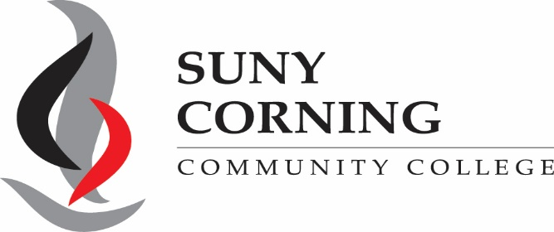

ASSOCIATE OF APPLIED SCIENCE NURSING PROGRAM CONFIDENTIAL RECOMMENDATION FORM
The applicant is a candidate for admission to the Direct-Entry Nurse Education Program.
Please complete this form and return to the Nurse Education Department via email at cccnursing@corning-cc.edu.
.

Applicant: Please complete the following section

Last Name First Middle

Permanent Address

City State Zip Code

Pursuant to the federal law, a student admitted to Corning Community College, Nurse Education Program is entitled to inspect the recommendation unless the student waives the right. The Nurse Education Department does not require a waiver as a condition for admission, receipt of financial aid or receipt of any other services or benefits.

Waiver

The Family Education Rights and Privacy Act permits us to request, but not require that a student waive the right to inspect this recommendation. Be advised that the information contained on this form is used to evaluate the student’s eligibility for admission to Corning Community College, Nurse Education Program. Should the students elect to waive the right to access and review this information please sign and date below:

Signature Date

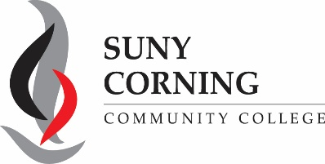

Recommendation Form

Applicant name: __________________________________________________

In what capacity have you known the applicant?

How long have you known the applicant?

Estimate of applicant’s future success in Corning Community College Direct-Entry Nurse Education Program: Superior Above Average May Encounter Difficulty _ Little Chance of Success
Please indicate whether or not you endorse the applicant as a suitable candidate for nursing.

Endorse with enthusiasm
Endorse with reservation
Do not endorse

Please rate the applicant on the following:

 | Strong | Average | Weak | Unable to Evaluate
Academic Preparation
Communication Skills
Critical Thinking
Integrity
Interpersonal Skills
Leadership
Self-Direction
Time Management

Evaluator Remarks

Please state any evidence to support your recommendation of the student to SUNY Corning Community College Direct-Entry Nurse Education program using this form or additional paper. Your comments should address the
student’s academic ability, personal character and information relevant to the student’s ability to perform college-level work.

Your Name Date

Your Signature Your Job/Position

Your Company/Place of Employment

Telephone Number(s) Daytime Other E-mail

This form is for information gathering. The content alone does not determine acceptance to the Nursing Program.

132 Denison Parkway East * Corning, NY 14830 * (607) 937-1323 * fax (607) 937-1308

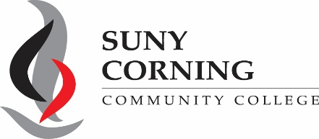

ASSOCIATE OF APPLIED SCIENCE NURSING PROGRAM CONFIDENTIAL RECOMMENDATION FORM
The applicant is a candidate for admission to the Direct-Entry Nurse Education Program.
Please complete this form and return to the Nurse Education Department via email at cccnursing@corning-cc.edu.

Applicant: Please complete the following section

Last Name First Middle

Permanent Address _ City State Zip Code

Pursuant to the federal law, a student admitted to Corning Community College, Nurse Education Program is entitled to inspect the recommendation unless the student waives the right. The Nurse Education Department does not require a waiver as a condition for admission, receipt of financial aid or receipt of any other services or benefits.

Waiver

The Family Education Rights and Privacy Act permits us to request, but not require that a student waive the right to inspect this recommendation. Be advised that the information contained on this form is used to evaluate the student’s eligibility for admission to Corning Community College, Nurse Education Program. Should the students elect to waive the right to access and review this information please sign and date below:

Signature Date

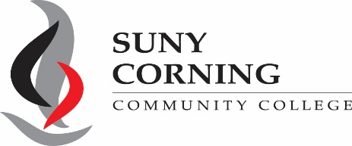

Recommendation Form

Applicant name: ________________________________________________________

In what capacity have you known the applicant?

How long have you known the applicant?

Estimate of applicant’s future success in Corning Community College Direct-Entry Nurse Education Program: Superior Above Average May Encounter Difficulty Little Chance of Success
Please indicate whether or not you endorse the applicant as a suitable candidate for nursing.

Endorse with enthusiasm
Endorse with reservation
Do not endorse

Please rate the applicant on the following:

 | Strong | Average | Weak | Unable to Evaluate
Academic Preparation
Communication Skills
Critical Thinking
Integrity
Interpersonal Skills
Leadership
Self-Direction
Time Management

Evaluator Remarks

Please state any evidence to support your recommendation of the student to SUNY Corning Community College Direct-Entry Nurse Education program using this form or additional paper. Your comments should address the
student’s academic ability, personal character and information relevant to the student’s ability to perform college-level work.

Your Name Date

Your Signature Your Job/Position

Your Company/Place of Employment

Telephone Number(s) Daytime Other E-mail

This form is for information gathering. The content alone does not determine acceptance to the Nursing Program.

132 Denison Parkway East * Corning, NY 14830 * (607) 937-1323 * fax (607) 937-1308

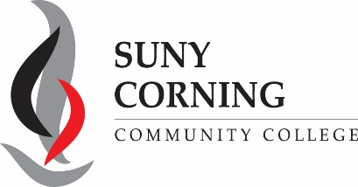

ASSOCIATE OF APPLIED SCIENCE NURSING PROGRAM

DIRECT-ENTRY PROGRAM
CONFIDENTIAL GUIDANCE COUNSELOR RECOMMENDATION FORM
The applicant is a candidate for admission to the Direct-Entry Nurse Education Program.
Please complete this form and return to the Nurse Education Department via email at cccnursing@corning-cc.edu, along with a copy of the applicant’s transcript.

Applicant: Please complete the following section

Last Name First Middle

Permanent Address

City State Zip Code

Pursuant to the federal law, a student admitted to Corning Community College, Nurse Education Program is entitled to inspect the recommendation unless the student waives the right. The Nurse Education Department does not require a waiver as a condition for admission, receipt of financial aid or receipt of any other services or benefits.

Waiver

The Family Education Rights and Privacy Act permits us to request, but not require that a student waive the right to inspect this recommendation. Be advised that the information contained on this form is used to evaluate the student’s eligibility for admission to Corning Community College, Nurse Education Program. Should the students elect to waive the right to access and review this information please sign and date below:

Signature Date

Guidance Counselor Recommendation Form

Current year courses student is taking, please indicate title and level (IB, AP, Honors) of all courses the student is taking this year?

HS graduation date? Does your school rank students? if so, this candidate would rank

in class of students. This candidate has a cumulative GPA of on a scale. Estimate of applicant’s future success in Corning Community College Direct-Entry Nurse Education Program
Superior Above Average May Encounter Difficulty Little Chance of Success

Please indicate whether or not you endorse the applicant as a suitable candidate for nursing

Endorse with enthusiasm
Endorse with reservation
Do not endorse

Compared with other college bound students with whom you have experience, please indicate your perception of the applicant’s attributes

 | Strong | Average | Weak | Unable to Evaluate
Academic Preparation
Work ethic
Integrity
Interpersonal Skills
Leadership
Respect for others
Service to others

Guidance Counselor Remarks

Please state any evidence to support your recommendation of the student to SUNY Corning Community College Direct-Entry Nurse Education program using additional paper. Your comments should address the student’s academic ability, personal character and information relevant to the student’s ability to perform college-level work.

Your Name Date

Your Signature Guidance Phone Number

Place of Employment E-mail

This form is for information gathering. The content alone does not determine acceptance to the Nursing Program.

132 Denison Parkway East * Corning, NY 14830 * (607) 937-1323 * fax (607) 937-1308

